Configuring the NL241 wireless router

*\*last updated June 2019*

*\*This is all explained in the user manual stored here (T:\SIGEO\Met tower) but this is an easier explanation. Best to use this guide but refer to the full manual for any clarification.*

**Connection to Power**

The NL241 in the box did not come with a power cable, as Campbell Scientific apparently either assumes you have one or that you will buy it from them. We determined that it takes a standard DC 12V, 1A connection.

* In office, it needs to be powered by direct connection wall plug before you do any configuration. We used a plug that came with a magnet spinner (chemistry) appliance. These plugs are pretty common.
* In field, it must be powered from the same power source as the LoggerNet, which is the + (black) and – (red) connections. Either you have to buy raw cables for it, or you cut a wire so the + and – are exposed, sodder them with a soddering iron (we have in office), and put in to the power source.
  + It is a tight fit with both the LoggerNet’s and NL241’s cables fit into the space, but it can work.
  + 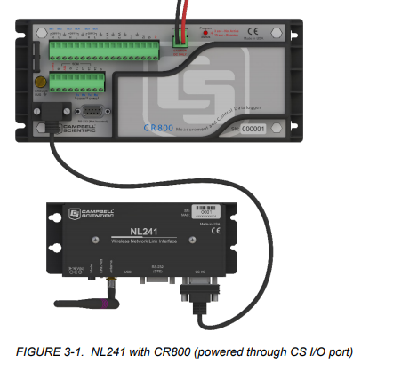Notice how unhelpful this picture is, because it gives no indication the NL241 needs to be connected to that power source.

**Configuration**

Follow these steps to change

* Wifi password
* Wifi network name
* The IP address

To configure the NL241 for the first time (or to change any settings on it),

1. Install [DevConfig](https://www.campbellsci.com/devconfig) and download the USB driver (requires admin access)
   1. To download from Campbell Scientific, username: [mcgregori@si.edu](mailto:mcgregori@si.edu), pw: forestGEO1
2. Connect NL241 to power, have light turn green, then connect to computer via USB cord
3. Open DevConfig
4. Under **Device Type**, select **Network Peripheral | NL241**
5. Change the **Communication Port** to highlight the option **NL241** and click OK.
6. Click Connect.
7. To change Wifi settings, click on the Wifi tab. To change anything else, click on the NL241 tab.
8. If you’ve changed anything, click **Apply.** Otherwise, just cancel out of everything.
9. Make sure before you go in field that your phone/tablet can find the wifi network created by the NL241.